**Practical No. 7**

**Aim: To perform BCD to Excess­3 conversion.**

**Apparatus:** Logic Gate ICs, Connecting wires, Bread Board, Power supply, LED, DMM.

**Theory:**

We will complete this experiment to code converters by designing an Excess­3 Binary Coded Decimal (BCD) circuit. The term BCD refers to representing the ten decimal digits in binary forms; which simply means to count in binary; see Table below. The Excess­3 system simply adds 3 to each number to make the codes look different. We will not venture to discuss the importance of the Excess­3 BCD system because the discussion would serve too great a distraction from our present purpose and the cost would outweigh the benefit. Suffice it to say that the Excess­3 BCD system has some properties that made it useful in early computers.

The Excess­3 BCD system is formed by adding 0011 to each BCD value as in Table. For example, the decimal number 7, which is coded as 0111 in BCD, is coded as 0111+0011=1010 in Excess­3 BCD.

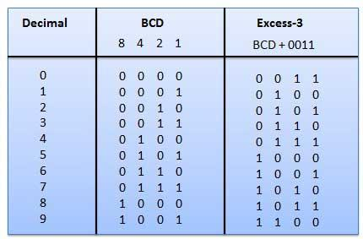

**Tinker Cad Simulation:**

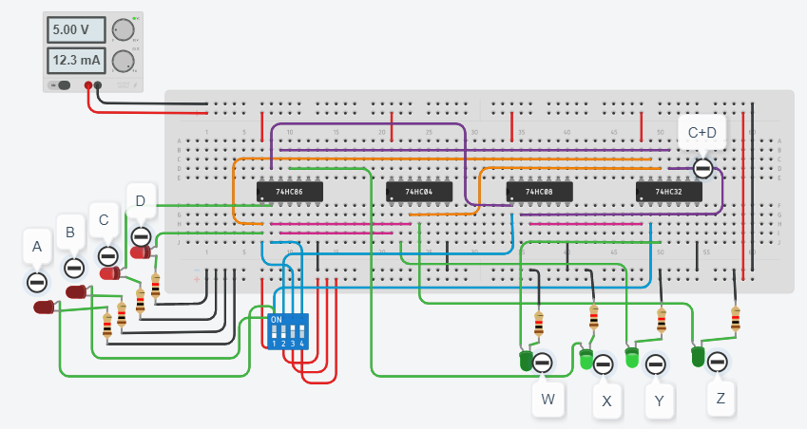

**CONCLUSION:**

Excess-3 binary code is a unweighted self-complementary BCD code. Self-Complementary property means that the 1’s complement of an excess-3 number is the excess-3 code of the 9’s complement of the corresponding decimal number. This property is useful since a decimal number can be nines’ complemented (for subtraction) as easily as a binary number can be ones’ complemented; just by inverting all bits.